

**PROJECT BASED LEARNING**

**at**

**SUPERIOR GOLD CAMPUS**

**PLAN 2020**

|  |  |  |  |  |
| --- | --- | --- | --- | --- |
| **Document History** | | | | |
| **Rev. #** | **Date** | **Approved By** | **Release by and Date** | **Next Review Date** |
| R-1.0 |  |  |  |  |
| R-1.1 |  |  |  |  |
| R-1.2 |  |  |  |  |

|  |  |  |  |
| --- | --- | --- | --- |
| **Prepared by** | **Reviewed by** | **Approved By** | **Authorized By** |
| **M. Zaman Aziz** | **Dr. Arffan Jaffer**  Dean CS&IT | **­­­­­_____________________**  CEO – InfinIT Connections | **_______________________**  **Prof. Dr. Ch. Abdul Rehman**  Chairman – Superior Group |
|  | **Madam Ayesha Zahid** |
| **Razi - InfiniT Connections** |

EXECUTIVE SUMMARY

1. Ensure that students embark on IT solutions, products and services-based projects.
2. Improve quality of students’ projects based on industry projects.
3. The projects shall be carried out under strict supervision of the teacher and the senior management of the Gold campus.
4. Teacher will ensure student success and employability through best practices and coaching.
5. The engaged teacher will get more rewards in terms of promotion and salary benefits.
6. Commercialized project shall be sold by the InfinIT Connection or by the linked outreach at least once in a year.
7. Teacher can mark each milestone online.
8. In PBL-1, PBL-2, PBL-3 Exhibitions: projects will be evaluated by External Evaluator and Superior Connection will support Head of I&C to carry out these evaluations.
9. Project milestones and delivery will be checked at any time through the portal which is already in place.
10. PBL application is already deployed for conducting exhibitions and to enhance student’s quality.
11. PBL Managers can give up to 10% marks on UMS against PBL Subject exhibitions.

# VISION

To be a leading Pakistani university driving excellence in learning, innovation and research. We believe in developing emotionally intelligent Superheroes who can create social and economic impact through entrepreneurial mindset to build a Superior Pakistan.

# MISSION

We are committed to transform the lives of students, faculty and staff by providing them a superior learning experience. Our plan EQ & IQ enables them to lead a meaningful & rewarding life.

# VALUES

## Integrity Embody dependability, honesty, and transparency.

## Excellence

Our main priority is to challenge the issues of our country and providing the sustainable solution to these problems.

## Independence

We will work together to be financially independent and make our country superior.

## Teamwork

Teamwork is our main key through which we are providing IT solutions to the 21st century global problems.

# PURPOSE AND SCOPE

1. This procedure describes the Project Based Learning plan and Project Based Learning (PBL) activities performed by Faculty of CS&IT.
2. The PBL plan is required:
   1. To support and facilitate students in achieving success
   2. To deploy information technologies that increase overall organizational productivity and performance, achieve greater efficiencies and positive returns on the investment in technology; and,
   3. To ensure employability of the student
   4. To link the goals and objectives specified by Faculty of CS& IT to that of University

# DEFINITIONS AND ABBREVIATIONS

|  |  |  |
| --- | --- | --- |
| **Abbreviation** | **Definition** | **Scope** |
| PBL | Project (FYPs) Based Learning | PBL is used for |
| DoF | Dean of Faculty | Cater all types of project listed in InfinIT Lab’s project |
| HIC | Head of Innovation and Commercialization | Initiate and follow up the project registration process |
| HoD | Head of Department | Carry out the commercialization Plan Procedures |
| PLM | PBL Manager | Project kick-off and Exhibition execution |
| PLT | Project Based learning Teacher | Teacher who will teach Project Based Learning Subject |
| QCH | Quality Circle Head | Ensure Project Quality in Subjects |
| FAC | Respective Faculty |  |

# TECHNOLOGY STACK

A Technology Stack is a set of tools that are used to construct and power an application. It consists of a combination of software applications, frameworks, and programming languages that realize some aspects of the program. PBL Program at Superior University will follow Latest Technology Stack in Students project in order to ensure Market readiness of its Students. “Gartner Hype Cycle” may be an effective approach to establish Technology stack for PBL project.

# A committee of expert is purposed to establish Technology stack for PBL program.

# PBL Value Proposition Canvas for Employability

Employability is one of the Superior strategic aims, as part of the “Student Success” agenda. The PBL Program regards developing skills in life-long learning, the business environment and entrepreneurship as key outcomes from students’ experience at superior university.

PBL give superior students the opportunity to develop their employability skills including their team working skills within a practically oriented environment. As a team the students will be required to organize themselves to plan and carry out projects and put into practice knowledge from best Industry practices and standards in solving the problem will be presented.

# C:\Users\hi\Desktop\PBL2020\PBL.jpeg

Figure 1- Value Proposition Canvas for Employability

Table 1: PBL Student Segments

|  |  |  |
| --- | --- | --- |
| PBL Student Segments |  |  |
| Students Profile | Students Gain | Student Pain |
| Currently Student at Superior UniversityStudied all necessary Subject and technologies required by market but lack ofPractical Exposure often becomes great hurdle towards employability. | 1. Experience with hand on Project Exposure will increase Market Acceptability.2. Students will be Equip with stat of Art Tools and Technologies. | 1. It is always Changeling to learn new Technologies.2. Organize themselves to plan and carry out projects |

Table 2: PBL Value Map

|  |  |  |
| --- | --- | --- |
| PBL Value Map |  |  |
| PBL Impact | PBL Gain Creator | PBL Pain Reliever |
| 1. Ensuring “Student Success” through Employability.2. Produce Market Ready Students | 1. Greater Market Penetration2. Strengthen Market Base of Superior University. | Greater Number of Student will be accepted by Industry. Student pass out to Employability Ratio will increase.Superior is Not a Factory of Unemployed Youngsters |

# PROJECT STANDARDS

In order to gain an advantage, increase successful delivery of assigned project, we must stay abreast of the latest standards techniques that have proven to be successful for project around the globe. PMI (Project Management Institute), is an internationally recognized standard that reflect best practices and knowledge areas for effective project management. Following knowledge areas are recommended for PBL1 and PBL2.

**Project Scope Management.** Includes the processes required to complete the project successfully. Following processes are recommended.

1. Understand the context (environment, circumstances, processes) of the problem and user
2. Explore the three focus areas, Viability, Feasibility, and Desirability

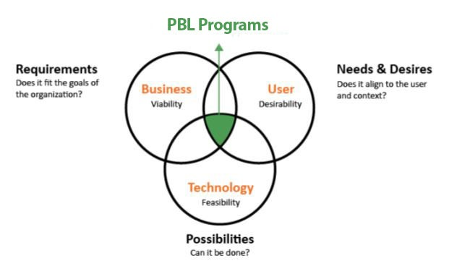

Figure 2: Project standards

# Project Communications Management. Communications describe the possible means by which the information can be sent or received, either through communication activities, such as meetings and presentations, or artifacts, such as emails, social media, project reports, or project documentation.

# ROLES & RESPONSIBILITIES

The following personnel have responsibilities mentioned in this procedure:

## Head I&C

* + 1. Initiate and follow up the project registration process for logging in the upcoming semester projects register.
    2. Meet or exceed deadlines for deliverables using updated web portal to capture projects allotments, rubric based project information, review and approvals by the relevant stakeholders.
    3. Confirm preventive / proactive reminders to all the stakeholders to carry out their activities through web portal and maintain record of overdue actions.

## HoD Office

* + 1. Respective departmental HoD’s office is responsible for working with I&C Management to carry out the PBL Plan Procedures
    2. Confirm KPI’s set for the Projects’ group (Teacher) to achieve the project wise objectives and increase the efficiency by enhancing quality of projects (products or services).
    3. Confirm the following:
    - On time submission of project scope to I&C
    - Project shall kick off in the first week of the semester
    - Continuous health check of the on-boarded projects in line with the defined milestones.
    - On time submission of iterations from faculty of CS & IT through portal
    - Ensure accountability of each PBL faculty member on catching deadlines

## Dean’s Office (CS&IT)

1. Responsible for working with I&C Management to carry out the PBL Plan Procedures
2. Ensuring that I&C Manager is achieving set KPIs
3. Ensure KPI’s set for the Projects’ group (Teacher) to achieve the project wise objectives and increase the efficiency by enhancing quality of projects (products or services).
4. Ensure the following:
   * + On time submission of project scope to I&C
     + Project shall kick off in the first week of the semester
     + Continuous health check of the on-boarded projects in line with the defined milestones
     + On time submission of iterations from faculty of CS & IT from portal
     + Ensure that each faculty member will mark iterations on portal timely so that Head I&C will ensure catching deadlines
     + Ensure accountability of each faculty member on catching deadlines

## PBL Managers

1. Working under HOD-I&C. Their role will be to conduct exhibition for PBL-1, PBL-2, and PBL-3 Exhibition.
2. Prepare project list and work closely with CMACED, InfiniT Connection in order to find design challenges
3. Working closely with PBL teachers to ensure unbiased assessment.
4. Ensure same rubrics in all classes for PBL-1, PBL-2 and PBL-3
5. Responsible for the following:
   * + Project shall kick-off within first week of the semester.
     + Continuous project health check of the on-boarded projects in line with the defined milestones.
     + On time submission of iterations from faculty of CS & IT from portal.
     + Each faculty member will mark iterations on portal timely so that Head I&C will ensure catching deadlines.

## 

## C:\Users\GQ\AppData\Local\Microsoft\Windows\INetCache\Content.Word\l11.png

## Objectives

Objective of PBL-1 is as follows:

* Enhance Problem Solving ability in the student through Empathize, Define Process.
* Enhance Critical Thinking in students by design challenges in projects
* Enhance Communication Skills in students
* Enhance Programming Construct Usage according to the scenarios
* Ability to understand failure in code through Debugging
* HOW MIGHT WE DESIGN SUCESSFUL PBL-1 APPROACH to ensure student success?

**Registration and Follow-up**

* Project Based Learning Manager will work with PLT for preparation of project list in the subject.
* Project Based learning Manager will submit project list to HoD I & C to ensure project quality.

## PBL-1 Guidelines

* For level -1, C++ will be used as Language
* Nature of Projects will management systems through file handling
* Student will select the project out of the list to ensure quality in each class
* Industry help is not required in this level and teacher will ensure project success
* Assessment will be done subject wise and teacher will be accountable for delivery of the projects
* HoD-I&C will initiate assessment phase after getting the selected list of projects by students and PBL Manager.

**CLO & PLO Mapping for PBL-1**

|  |  |  |  |
| --- | --- | --- | --- |
| Course Objectives | *The objective of this course is to enable students;* | | |
| No. | Objective | Relation with Program  Objectives |
|  | To impart the basic concepts of data structures and algorithms. | POL 1,2,3 |
|  | To understand concepts about searching and sorting techniques | POL 4,5 |
|  | To Understand basic concepts about stacks, queues, lists, trees and graphs. | POL 1-6 |
| 4. | To understanding about writing algorithms and step by step approach in solving problems with the help of fundamental data structures | POL 1-7 |
| Course Learning Outcomes (CLO) | *At the end of this course students will be able to demonstrate;* | | |
| No. | Outcome | Relation with SLO/PLO |
|  | Explain the need for efficiency in data structures and algorithms. | SLO 1 |
|  | Apply methods to analyze running time of essential data structures and estimate efficiency of the algorithms and implementations. | SLO 2 |
|  | Understand and apply the concept of abstract data type to represent and implement heterogeneous data structures. | SLO 2 |
|  | Write programs using array-based lists, write programs using linked lists, write programs that use skiplists. write code for hash tables, and compare and contrast various collision detection and avoidance techniques. | SLO 3 |
|  | Demonstrate skills in tracing, analyzing, and designing recursive algorithms and recursive methods. | SLO 3 |
|  |  | Write programs using binary trees and variations. | SLO 1-3 |
|  |  | Analyze and implement different types of sorting algorithms. | SLO 1-3 |
|  |  | Implement data structures for graphs and approaches for searching graphs using breadth-first, depth-first, best-first search, etc. | SLO 1-4 |

**Evaluation Rubrics**

Table 3: Project Based Learning Year-1

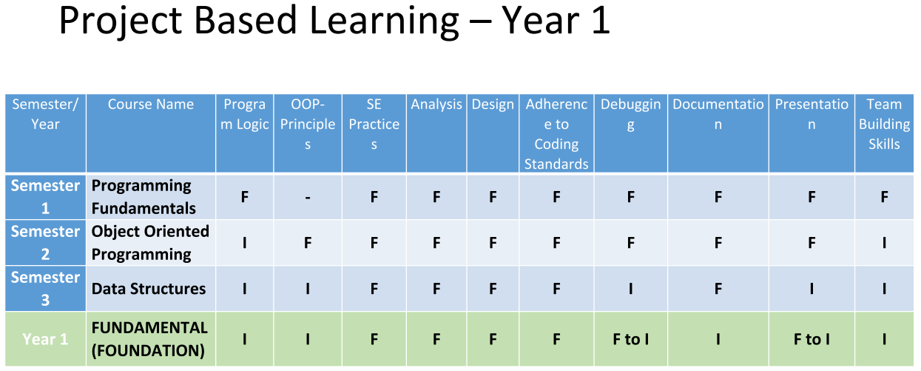

[**Programming Form Link**](https://docs.google.com/forms/d/e/1FAIpQLSePr7g0d2UTW6BKLozqXT8-Zj8jmRsrbC_lFg1_wsXe4eBz6Q/viewform)

[**OOP Form Link**](https://docs.google.com/forms/d/e/1FAIpQLSci-pe8vyyOwB4uRIeQsVpVy2nYQt2khYK-WlO8F8GKSQa1PA/viewform)

[**Data Structure Form Link**](https://docs.google.com/forms/d/e/1FAIpQLSfjLvU_sv720udiVNLWFsoEdbRE7SCBWMbfI6jOfsLfPlKlIA/viewform)

Table 4: Programming Mappings with CLOs

**POs, CLOs and PLOs Mapping defined here. Actual POs, PLOs, CLOs are defined in course outlines.**

|  |  |  |
| --- | --- | --- |
| *The objective of this course is to enable students;* | | |
| No. | **Objective** | Relation with Program  Objectives |
|  | To design algorithms to solve simple problem using tools like pseudocode, flow charts, and desk checking | PO1, PO2 |
|  | To implement algorithmic logic in programming language | PO2 |
|  | To correct, test and debug computer programs | PO2 |
|  | To explain how algorithms and computer programs work | PO2 |
|  | To demonstrate the basic structured programming in a team oriented environment by conducting a term project | PO4, PO6 |
| *At the end of this course students will be able to;* | | |
| No. | **Class Learning Outcome** | Relation with PLO |
|  | Apply basic programming principles in C++ programming language, construct C++ programming structure using programming fundamentals and principles. | PLO1, PLO2, PLO3 |
|  | Analyze complex problems and synthesize suitable solutions that accommodate specified requirements and constraints, based on analysis or modelling or requirements specification. | PLO2, PLO3, PLO5 |
|  | Create programming designs which includes step-by-step algorithms and desk checking to validate problem solutions. | PLO2 |
|  | Incorporate the use of sequential, selection and repetition control structures into the algorithms implemented as computer programs | PLO2 |
|  | Demonstrate an understanding of structured design by implementing programs with functions and passing of parameters to solve more complex problems and to promote the concept of efficient use of code | PLO3, PLO5, PLO10 |
|  | Design and implement programs using arrays and string object | PLO2, PLO3, PLO5 |
|  | Ability to implement small scale projects in small groups and communicate it effectively in lab project presentation. | PLO9 |

Table 5: Programming Iteration Submissions

|  |  |  |  |  |
| --- | --- | --- | --- | --- |
| ITERATION NO | DELIVERABLE | DATE | CLO Mapping | PLO Mapping |
| GROUP FINALIZED | **Group handed over to I & C through portal** | **1st Week** | **CLO7** | **PLO9** |
| * Problem Identification * Logic Building * Flowchart | **Submission online** | **4th Week** | **CLO1, CLO2** | **PLO1, PLO2** |
| * Functions * Menu Development * Console Interface * Conditionals * Loops | **Submission online** | **8th Week** | **CLO3, CLO5** | **PLO3, PLO5, PLO10** |
| * File Handling * Debugging * Dry Run Skill * Scenario Implementation | **Submission online** | **12th Week** | **CLO4, CLO5, CLO6** | **PLO3, PLO5, PLO10** |
| * 75% Development * Programming Construct Usage * Lines of code & syntax * Computation Skill | **Submission online** | **15th Week** | **CLO6, CLO7** | **PLO2,PLO3, PLO5, PLO9** |

Table 5: Object oriented programming

|  |  |  |  |
| --- | --- | --- | --- |
| Course Objectives | *The objective of this course is to enable students;* | | |
| No. | Objective | Relation with Program  Objectives |
|  | At the end of the class, we expect people to have a good understanding about the concept of object-oriented programming using C++, be able to write and read basic C++ code. | PLO 1, 2, 3 |
|  | Using inheritance and polymorphism to manage the source code. | PLO 4, 5 |
|  | Student will be motivated and encouraged to choose a practical project which should be management system or transactional system. | PLO 1-6 |
| Course Learning Outcomes (CLO) | *At the end of this course students will be able to demonstrate;* | | |
| No. | Outcome | Relation with SLO/PLO |
|  | Understand the relative merits of C++ as an object oriented programming language | PLO 1, 2, 3 |
|  | Understand the features of C++ supporting object oriented program | PLO 4, 5 |
|  | Understand how to produce object-oriented software using C++ | PLO 6, 10, 11 |
|  | Understand how to apply the major object-oriented concepts to implement object oriented programs in C++, encapsulation, inheritance and polymorphism | PLO 8, 12 |
|  | Understand advanced features of C++ specifically stream I/O, templates and operator overloading | PLO 6, 7, 9 |

Table 6: Object Oriented programming Iteration Submission

|  |  |  |  |  |
| --- | --- | --- | --- | --- |
| ITERATION NO | DELIVERABLE | DATE | CLO Mappings | PLO Mapping |
| GROUP FINALIZED | Group handed over to I & C through portal | 1st Week | CLO7 | PLO9 |
| ClassesConstructorDestructorSetter / GetterMenu Development Using Class | Submission online | 4th Week | CLO1, CLO2 | PLO1, PLO2 |
| Classes FunctionalityAbstractionInformation HidingCopy ConstructorComposition Scenario | Submission online | 7th Week | CLO3, CLO5 | PLO3, PLO5, PLO10 |
| Association ScenarioInheritance ScenarioAggregation Scenario**Operator Overloading Scenario****Friend Function Scenario** | Submission online | 11th Week | CLO4, CLO5, CLO6 | PLO3, PLO5, PLO10 |
| File Handling with Objects**Polymorphism Scenario**Templates ScenarioInterface Scenario | Submission online | 13th Week | CLO6, CLO7 | PLO2, PLO3, PLO5, PLO9 |
| Static Variables & Static Functions ScenarioArray of Object ScenarioStream Insertion OperatorStream Extraction operator | Submission online | 15th Week |  |  |

Table 7: Data Structure

|  |  |  |
| --- | --- | --- |
| ITERATION NO | DELIVERABLE | DATE |
| GROUP FINALIZED | Group handed over to I & C through portal | 1st Week |
| Introduction | Submission online | 4th Week |
| Related WorkDescription of the data-structures involvedProblem Identification | Submission online | 8th Week |
| Architecture of the Application**Algorithm Usage**Graphical User Interface (GUI)Selecting Best Data StructureProof of Correctness | Submission online | 12th Week |
| Coding Procedure**Design & implementation**ImplementationDebuggingTesting | Submission online | 15th Week |

## Review of Project

* HoD-I&C, Departmental HoD, Faculty, PBL Manager will review health of the project against the set milestones and KPIs (see KPI’s section for further detailing)
* Project evaluation will be recorded by PBL Teachers

## Approval of the Project

* QCH approves the list of best projects against PBL-1 for the PBL Exhibition

## Final Stage

* PBL Manager will conduct exhibition of the best projects chosen from repository. PBL-1 ends at 3rd Semester on Data Structure Project Exhibition

## Outcome

* Student will learn different stages of Requirement Engineering, Problem Solving, Critical Thinking through Project driven stages.

HoD-I&C will identify and reports the best PBL teachers, PBL Managers based on automated system.

# PROCEDURE FOR PBL- 1

Please see Process flow diagrams in Annexure A.

**LINK FOR PORTAL**

<http://Pbl.csit.superior.edu.pk>

# USER MANUAL FOR PBL Monitoring Application

## Please see Annexure B.

## 

## C:\Users\GQ\AppData\Local\Microsoft\Windows\INetCache\Content.Word\l22.png

## Objective

Objective of PBL-2 is as follows:

* + Student will be able to develop Applications (Desktop & Web Application)
  + Student will be able to take requirements from client through various requirement engineering techniques
  + Student will be able to communicate his project efficiently and effectively
  + Student will be able to develop Databases of the required project
  + Student will get ability to understand failure in code (Logical / Syntax) through Debugging
  + Identify best PBL teachers based on performance review from Portal
  + Identify best PBL Manager based on performance review from portal
  + HOW MIGHT WE DESIGN SUCESSFUL PBL-2 APPROACH to ensure student success?

**Registration and Follow-up**

* Project Based Learning Manager will work with PLT for preparation of project list in the subject.
* Project Based learning Manager will submit project list to HoD I & C to ensure project quality.
* There will be one Project for each course in PBL-2
* Student will develop Database of the same project in Database Subject
* Student will develop Web Application of the same project in Web Application Subject
* Student will develop Desktop Application of the same project in Advance Computer Programming
* Student will develop OOAD Report of the same project in OOAD Subject

## PBL-2 Guidelines

* In Database Subject, SQL Server Management Studio will be used as standard
* In Web Development Subject, Microsoft ASP.NET will be used as standard
* In Advance Computer Programming, Microsoft Desktop Application forms will be used as standard
* Nature of Projects will be web apps having scope to be projects of Database, Advance Computer programming
* Student will select the project given by Project Based Learning Manager out of the list to ensure same quality in every class
* Industry help is required in this level and PBL teacher will work closely with InfiniT Connection for better coding standards
* Assessment will be done subject wise and teacher will be accountable for delivery of the projects on portal
* HoD- I&C will initiate assessment phase after getting the selected list of projects by students and PBL Manager

**CLO & PLO Mappings for PBL-2**

|  |  |  |  |
| --- | --- | --- | --- |
| Course Objectives | *The objective of this course is to enable students;* | | |
| No. | Objective | Relation with Program  Objectives |
|  | To investigate principles of object-oriented software engineering | PEO-1 |
|  | To learn software development modeling tool, i.e. UML | PEO-3 |
|  | To gain problem analysis and design skills for better understanding of programming skills in an agile environment | PEO-2 |
|  | To learn design patterns and principles | PEO-1 |
| Course Learning Outcomes (CLO) | *At the end of this course students will be able;* | | |
| No. | Outcome | Relation with SLO/PLO |
|  | To apply software design patterns, Techniquesand UML modeling by developing a project analysis and design document for a ‘real world’ software system. | SLO 13,12,11,10 |
|  | To implement object-oriented software engineering techniques using UML modeling tool in a software project | SLO 2, |
|  | To understand and utilize different quality control and assurance techniques i.e. test plan, V & V, test cases. | SLO 4,5 |
|  | To demonstrate sufficient skills in proprietary and non-proprietary UML design tools | SLO 2 |
|  | To practice principles of object-oriented language to design a software project | SLO 1,6,7 |

**Evaluation Rubrics**

**PROJECT BASED LEARNING YEAR2**

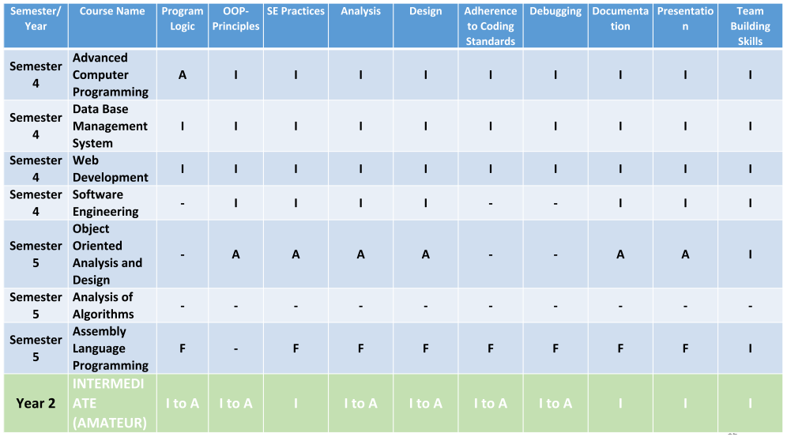

[**Web Application Development Link Form**](https://docs.google.com/forms/d/e/1FAIpQLScYNx7-KNeYaeQRzzEy6M7i4LUrIWtdEM32VnzHEXXc--a2zA/viewform)

[**Advanced Computer Programming Form Link**](https://docs.google.com/forms/d/e/1FAIpQLScYNx7-KNeYaeQRzzEy6M7i4LUrIWtdEM32VnzHEXXc--a2zA/viewform)

[**Database Form Link**](https://docs.google.com/forms/d/e/1FAIpQLSclvPn7jNJrDTKRLF7_3sZ6zp0VZgR4ZRwZUtGpTwrW8J4-Mw/viewform)

[**OOAD Form Link**](https://docs.google.com/forms/d/e/1FAIpQLSdSzinBN2riIcVwaJ7NRopYE4Itqz8TVfZ9CyZbnRfk5XFosQ/viewform)

[**Level-2 Exhibition Rubrics Form Link**](https://docs.google.com/forms/d/e/1FAIpQLScYNx7-KNeYaeQRzzEy6M7i4LUrIWtdEM32VnzHEXXc--a2zA/viewform)

Table 7: Database Iteration Submissions

CLOs and PLOs mapping are defined in respective course outlines.

|  |  |  |
| --- | --- | --- |
| ITERATION NO | DELIVERABLE | DATE |
| GROUP FINALIZED | Group handed over to I & C through portal | 1st Week |
| ERD Development after Requirement Engineering | Submission online | 4th Week |
| 25% DevelopmentERD Review | Submission online | 6thWeek |
| 50% DevelopmentPhysical Model in SQL ServerRequirement Completion through Store Procedures and Database forms | Submission online | 12th Week |
| 75% Development of requirementIntegration of Database project with same project in Web and Desktop application | Submission online | 15th Week |

Table 8: Web Development Iteration Submissions

|  |  |  |
| --- | --- | --- |
| ITERATION NO | DELIVERABLE | DATE |
| GROUP FINALIZED | Group handed over to I & C through portal | 1st Week |
| Presentation layerWeb Form Development | Submission online | 5thWeek |
| Business Logic Layer (50%) | Submission online | 11thWeek |
| Database Integration with Business Logic Layer | Submission online | 13th Week |
| ImplementationDebuggingTesting | Submission online | 15th Week |

Table 9: Advance Computer programming

|  |  |  |
| --- | --- | --- |
| ITERATION NO | DELIVERABLE | DATE |
| GROUP FINALIZED | Group handed over to I & C through portal | 1st Week |
| Presentation layerForm Development | Submission online | 5th Week |
| Business Logic Layer (50%) | Submission online | 11th Week |
| Database Integration with Business Logic Layer | Submission online | 13th Week |
| ImplementationDebuggingTesting | Submission online | 15th Week |

Table 10: OOAD / SOFTWARE ENGINEERING

|  |  |  |
| --- | --- | --- |
| ITERATION NO | DELIVERABLE | DATE |
| GROUP FINALIZED | Group handed over to I & C through portal | 1st Week |
| Requirement Specification Document | Submission online | 5th Week |
| Use case Diagram & Use case Specification | Submission online | 11th Week |
| Sequence Diagram, Activity Diagram, prototype Development in Balsamiq/ Just in mind Design Thinking Feedback process, UML Diagram | Submission online | 13th Week |
| Complete Report | Submission online | 15th Week |

## Review of Project

* HoD- I&C, Departmental HoD, Faculty, PBL Manager will review health of the project against the set milestones and KPIs (see KPI’s section for further detailing)
* Project evaluation will be recorded by PBL Teachers

## Final Stage

* PBL Manager will conduct exhibition of the best projects chosen from repository. PBL-2 ends in 5th Semester.

## Approval of the Project

* QCH approves the list of best projects against PBL-2 for the PBL Exhibition

## Outcome

* Student will learn Application Development (Desktop, Web, Database) with more focused approach
* HoD-I&C will identify and reports the best PBL Teachers, PBL Managers based on automated system
* Design Challenges solved at this stage can be used for commercialization as well as for organizational purpose

# PROCEDURE FOR PBL- 2

Please see Process flow diagrams in Annexure A.

**PROTOCOL FOR MONITORING**

Monitoring of each section, students and teacher will be ensured using PBL Portal.

**LINK FOR PORTAL**

<http://Pbl.csit.superior.edu.pk>

# USER MANUAL FOR PBL Monitoring Application

Please see Annexure B.

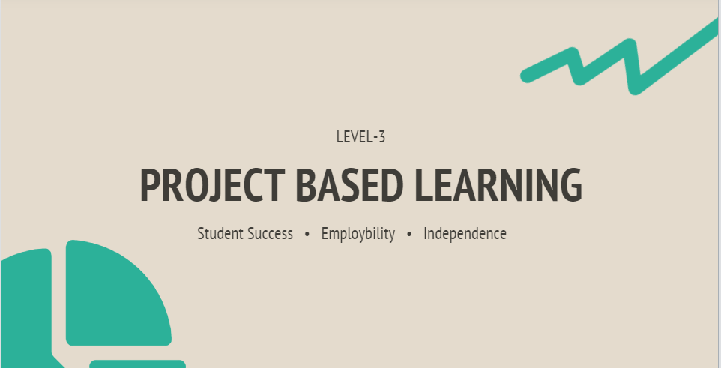

## Objective

Objective of PBL-3 is as follows:

* + Student will be able to develop Applications (Mobile Apps)
  + Student will be able to complete prototypes of Technopreneurship (Potential Good Projects will be identified for commercialization)
  + Student will be able to take requirements from client through various requirement engineering techniques
  + Student will be able to communicate his project efficiently and effectively
  + Student will be able to integrate open source api’s
  + Student will be able to develop Design Challenges that are Feasible / Viable and Desirable
  + Student will get ability to understand failure in code (Logical / Syntax) through Debugging
  + Identify best PBL teachers based on performance review from Portal
  + Identify best PBL Manager based on performance review from portal
  + HOW MIGHT WE DESIGN SUCESSFUL PBL-3 APPROACH to ensure student success?

**Registration and Follow-up**

* Project Based Learning Manager will work with PLT for preparation of project list in the subject
* Project Based learning Manager will submit project list to HoD I & C to ensure project quality

## PBL-3 Guidelines

* In Mobile Application Subject, Android Studio will be used as standard
* Nature of Projects will be Mobile apps / Innovative ideas in Technopreneurship / Project Integration
* Student will select the project given by Project Based Learning Manager out of the list to ensure same quality in every class
* Industry help is required in this level and PBL teacher will work closely with InfiniT Connection for better coding standards
* Assessment will be done subject wise and teacher will be accountable for delivery of the projects on portal
* HoD- I&C will initiate assessment phase after getting the selected list of projects by students and PBL Manager

**CLO Mappings PBL-Level 3**

|  |  |  |  |  |
| --- | --- | --- | --- | --- |
| Course Learning Outcomes (CLO) | *At the end of this course students will be able to;* | | | |
| No. | Outcome | Blooms Taxonomy | PLOs |
|  | Identify, develop and **Assess** entrepreneurial opportunity that creates economic and social value addition. | C6 | PLO1,4,6,8b |
|  | **Defend** entrepreneurial idea through pitch. | A5 | PLO3 |
|  | **Organize** self and team in relation to entrepreneurial leadership | A4 | PLO2,5,8a |
|  | **Demonstrate** entrepreneurial idea through prototype (MVP). | P4 | PLO1,4,6,8b |

**Evaluation Rubrics**

**PROJECT BASED LEARNING YEAR3**

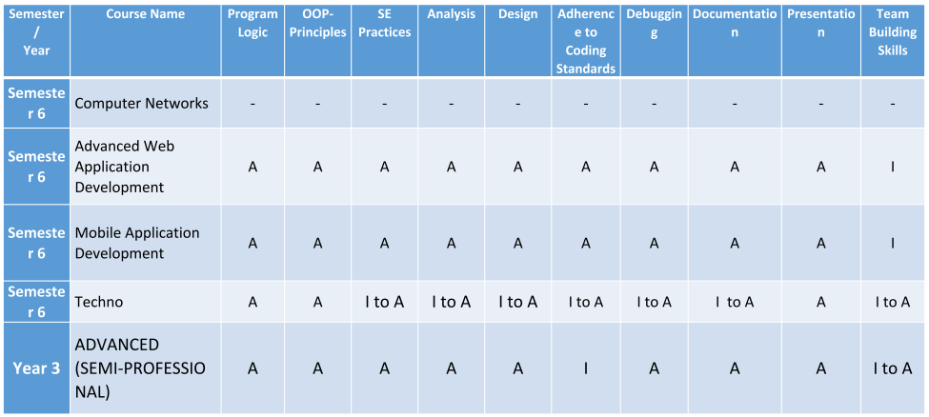

[**Advanced Web Application Development Form Link**](https://docs.google.com/forms/d/e/1FAIpQLSdrhJ6wf1-_NkXvnH5QqvUEbvtQQ1IUecEXGfsJZWqkV3plrw/viewform)

[**Mobile Application Development Form Link**](https://docs.google.com/forms/d/e/1FAIpQLSfEZ9TpjuJeSwcJmSBl7kRNi7GanqoeKEhwtq7l6rkqdPQm9g/viewform)

Table 11: Mobile Application Iteration Submissions

|  |  |  |
| --- | --- | --- |
| ITERATION NO | DELIVERABLE | DATE |
| GROUP FINALIZED | Group handed over to I & C through portal | 1st Week |
| Presentation layerWeb Form Development | Submission online | 5th Week |
| Business Logic Layer (50%) | Submission online | 11th Week |
| Database Integration with Business Logic Layer | Submission online | 13th Week |
| ImplementationDebuggingTesting | Submission online | 15th Week |

Table 12: Advance Web Development Iteration Submissions

|  |  |  |
| --- | --- | --- |
| ITERATION NO | DELIVERABLE | DATE |
| GROUP FINALIZED | Group handed over to I & C through portal | 1st Week |
| Presentation layerWeb Form Development | Submission online | 5th Week |
| Business Logic Layer (50%) | Submission online | 11th Week |
| Database Integration with Business Logic LayerWeb API Integration in your application (Payment API) | Submission online | 13th Week |
| ImplementationDebuggingTesting | Submission online | 15th Week |

## Review of Project

* HoD- I&C, Departmental HoD, Faculty, PBL Manager will review health of the project against the set milestones and KPIs (see KPI’s section for further detailing)
* Project evaluation will be recorded by PBL Teachers

## Final Stage

* PBL Manager will conduct exhibition of the best projects chosen from repository. PBL-3 will end at 6th Semester.

## Approval of the Project

* QCH approves the list of best projects against PBL-2 for the PBL Exhibition

## Outcome

* Student will learn Application Development (Mobile)
* HoD-I&C will identify and reports the best PBL Teachers, PBL Managers based on automated system
* Design Challenges solved at this stage can be used for commercialization as well as for organizational purposes.

# PROCEDURE FOR PBL- 3

Please see Process flow diagrams in Annexure A.

**LINK FOR PORTAL**

<http://Pbl.csit.superior.edu.pk>

# USER MANUAL FOR PBL Monitoring Application

Please see Annexure B.

..\PLANS\PBL Plan\pbl system user manual.docx

# KEY PERFORMANCE INDICATORS (KPIs)

|  |  |  |  |  |  |  |  |
| --- | --- | --- | --- | --- | --- | --- | --- |
| **KPIs** | **A** | **R** | **C** | **I** | **Frequency** | **Target** | **Control on KPIs** |
| On time Group Creation in each Class | PBL Teacher | PBL Manager | HoD |  | Yearly | 80% | PBL Report on Portal |
| On time iteration submission | PBL Teacher | PBL Manager |  |  |  |  |  |
| Performance review from PLM |  |  |  |  | Semester | 80% | Portal Report, HoD Report |
| On time Evaluation & Assessment | PBL Teacher | PBL Manager |  |  | Monthly | 90% | Portal Report, HIC Report |

# Annexures

Table 13: Process Flow forPBL-1

|  |  |  |  |  |  |  |  |
| --- | --- | --- | --- | --- | --- | --- | --- |
| **Process Flow forPBL-1(Functions)** | | **Initiation** | **Selection** | **Review** | **Approval** | **Final Stage** | **Outcome** |
| **Role / Timeline** | | **1st Week** | **2 weeks** | **Milestones Review** | **2 weeks before Exam** | **2 weeks before Exam** |  |
| **I&C Management** | Distribution of Project Form (PBL-1) [1] | Head of Innovation & Commercialization | List of Project for Assessment  Phases  (Rubrics) portal) | Evaluation &Assessment  On portal |  |  | PBL Repository [3] |
| **HODs** |  | Health check on portal on project quality | Reviews & Health check on portal | HOD Approval |  | Best HOD in Gold Campus |
| **InfinIT Connection** |  |  |  |  |  |  |
| **Students** | Project list to Student | Select Projects  (2nd week) |  |  |  |  |
| **PBL Teachers** | Project form to Teachers |  | Marks of projects on UMS |  | PBL Exhibition |  |
| **PBL Manager** |  | List of Projects to ensure quality  (1st week) |  |  |  |  | Best PBL Manager |
| **Dean (CS & IT)** |  |  |  |  |  |  | Report on KPIs |

Table 14: Process Flow forPBl-2

|  |  |  |  |  |  |  |  |  |
| --- | --- | --- | --- | --- | --- | --- | --- | --- |
| **Process Flow forPBL-2(Functions)** | | **Initiation** | **Selection** | **Review** | **Approval** | **Final Stage** | **Outcome** | **INFINIT Connection Outreach** |
| **Role / Timeline** | |  | **2 weeks** | **Milestones Review** | **2 week before Exam** | **2 weeks before Exam** |  |  |
| **I&C Management** | Distribution of Project Form (PBL-2) [1] | Head of Innovation & Commercialization | List of Project for Assessment  Phases  (Rubrics) portal) | Evaluation &Assessment  On portal |  |  | PBL Repository [3] | Best Faculty Member [3] |
| **HODs** |  | Health check on portal on project quality | Reviews & Health check on portal | HOD Approval |  | Best HOD in Gold Campus |  |
| **InfinIT Connection** |  |  |  |  |  |  | List of Best Projects |
| **Students** | Project list to Student | Select Projects  (2nd week) |  |  |  |  |  |
| **Faculty & PBL Manager** | Project form to Teachers |  | Marks of projects on UMS |  | PBL Exhibition |  |  |
| **PBL Manager** |  | List of Projects to ensure quality  (1st week) |  |  |  |  | Quality Circle head performance |  |
| **Dean (CS & IT)** |  |  |  |  |  |  | Report on KPIs |  |

Table 15: Process Flow forPBL-3

|  |  |  |  |  |  |  |  |  |
| --- | --- | --- | --- | --- | --- | --- | --- | --- |
| **Process Flow forPBL-3(Functions)** | | **Initiation** | **Selection** | **Review** | **Approval** | **Final Stage** | **Outcome** | **INFINIT Connection Outreach** |
| **Role / Timeline** | |  | **2 weeks** | **Milestones Review** | **2 week before Exam** | **2 week before Exam** |  |  |
| **I&C Management** | Distribution of Project Form (PBL-3) [1] | Head of Innovation & Commercialization | List of Project for Assessment  Phases  (Rubrics) portal) | Evaluation &Assessment  On portal |  |  | PBL Repository [3] | Best Faculty Member [3] |
| **HODs** |  | Health check on portal on project quality | Reviews & Health check on portal | HOD Approval |  | Best HOD in Gold Campus |  |
| **CMACED** | List of Projects to ensure quality  (1st week) |  |  |  | PBL Exhibition |  | List of Best Projects |
| **Students** | Project list to Student | Select Projects  (2nd week) |  |  |  |  |  |
| **PBL Manager** |  | Project form to Teachers |  | Marks of projects on UMS |  |  | Quality Circle head performance |  |
| **Dean (CS & IT)** |  |  |  |  |  |  | Report on KPIs |  |

Table 16: Process Flow forPBL-4

|  |  |  |  |  |  |  |  |  |  |
| --- | --- | --- | --- | --- | --- | --- | --- | --- | --- |
| **Process Flow forPBL-4(Functions)** | | **Initiation** | **Selection** | **Review** | **Approval** | **Final Stage** | **Outreach** | **Outcome** | **INFINIT Connection Outreach** |
| **Role / Timeline** | |  | **2 weeks** | **Milestones Review** | **2 week before Exam** | **2 week before Exam** |  |  |  |
| **I&C Management** | Distribution of Project Form (PBL-4) [1] | Head of Innovation & Commercialization | List of Project for Assessment  Phases  (Rubrics) portal) | Evaluation &Assessment  On portal |  |  |  | FYP Repository [3] | Best Faculty Member [3] |
| **HODs** |  | Health check on portal on project quality | Reviews & Health check on portal | HOD Approval |  |  | Best HOD in Gold Campus |  |
| **InfinIT Connection** | List of Projects to ensure quality  (1st week) |  |  |  | PBL-4  External Evaluation | Approval & Contract between outreach & Faculty |  | List of Best Projects |
| **Students** | Project list to Student | Select Projects  (2nd week) |  |  |  |  |  |  |
| **Faculty & FYP Manager& Outreach** | Project form to Teachers |  | Marks of projects on UMS |  |  |  |  |  |
| **Quality Circle Head** |  |  |  |  |  |  |  | Quality Circle head performance |  |
| **Dean (CS & IT)** |  |  |  |  |  |  |  | Report on KPIs |  |

**USER MANUAL**

User manual of the monitoring system is attached.